**UNT CSCE 5430 - Software Engineering**

**Assignment 3 - Microservices**

Dr.Lotfi ben Othmane

Overview

This assignment is a detailed information and practise on how the IIiJ IDEA functions about configuring and executing of the microservices with the help of Gradle.

**Functioning :**  
The functioning involves the processes of configuring and executing .

* Initially create a run configuration for Gradle.
* Then in intellij IDEA move towards the edit configurations.
* There on slightly top left you will find a plus click on it and then select Gradle.
* Give respective details like the name of the task.
* Then select the suitable Gradle project.
* Make sure you select the two tasks, clean and bootRun.
* Finally click on ok.

**Running:**

* You need to initiate this by selecting the task which is recently created from the drop down menu.
* Then click on the run button to start the execution of the microservice.
* We need to do the following for connecting to already running microservice. From menu , choose Files-> New->Project from Existing Sources.
* Then we choose the Gradle type and then choose the option open in separate/new window.
* Now, edit the configuration and do the required editing for the configuration.
* Create a separate all new profile and run the projects.

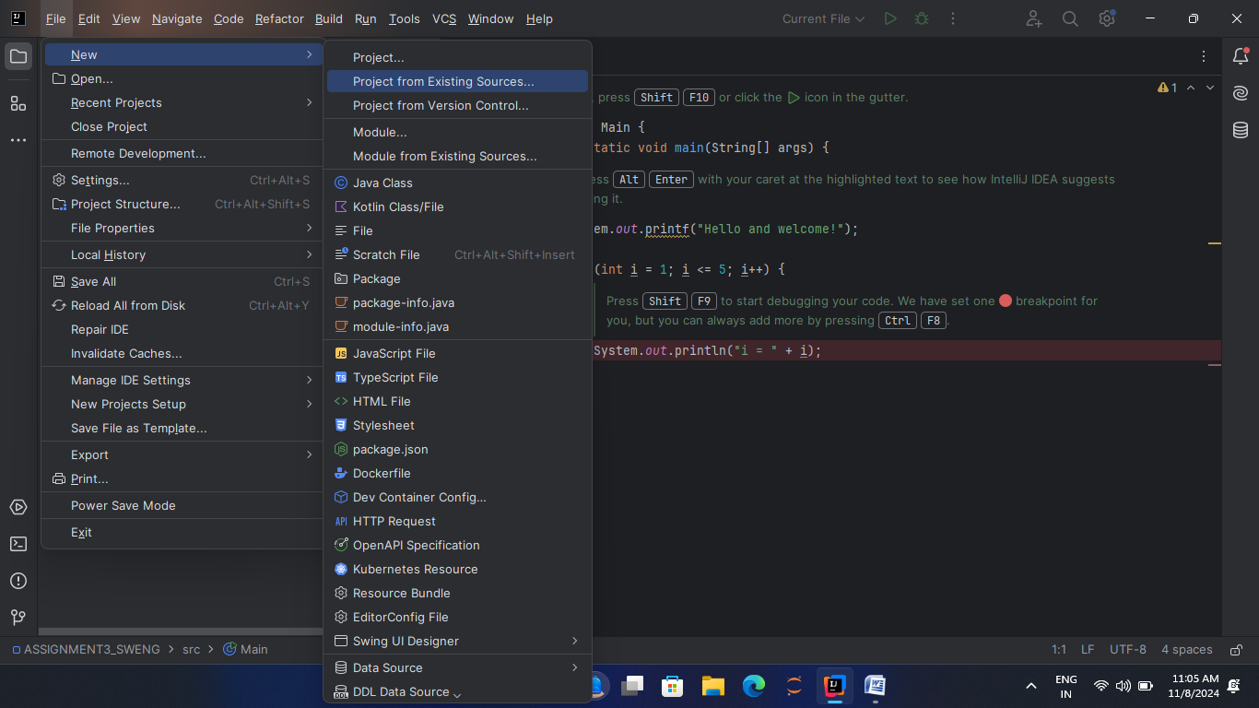

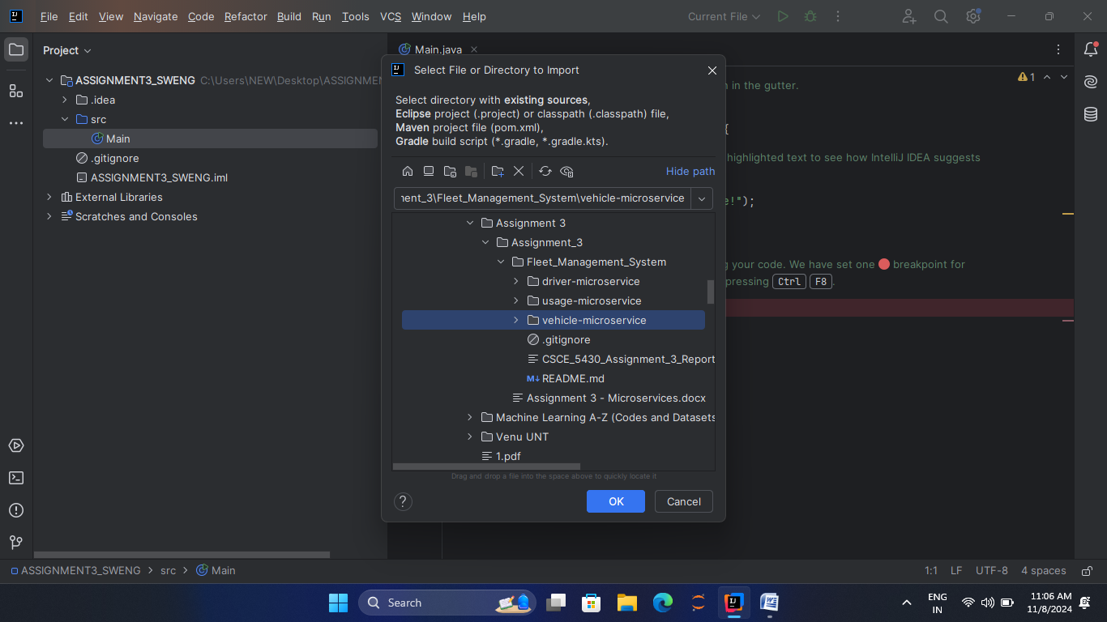

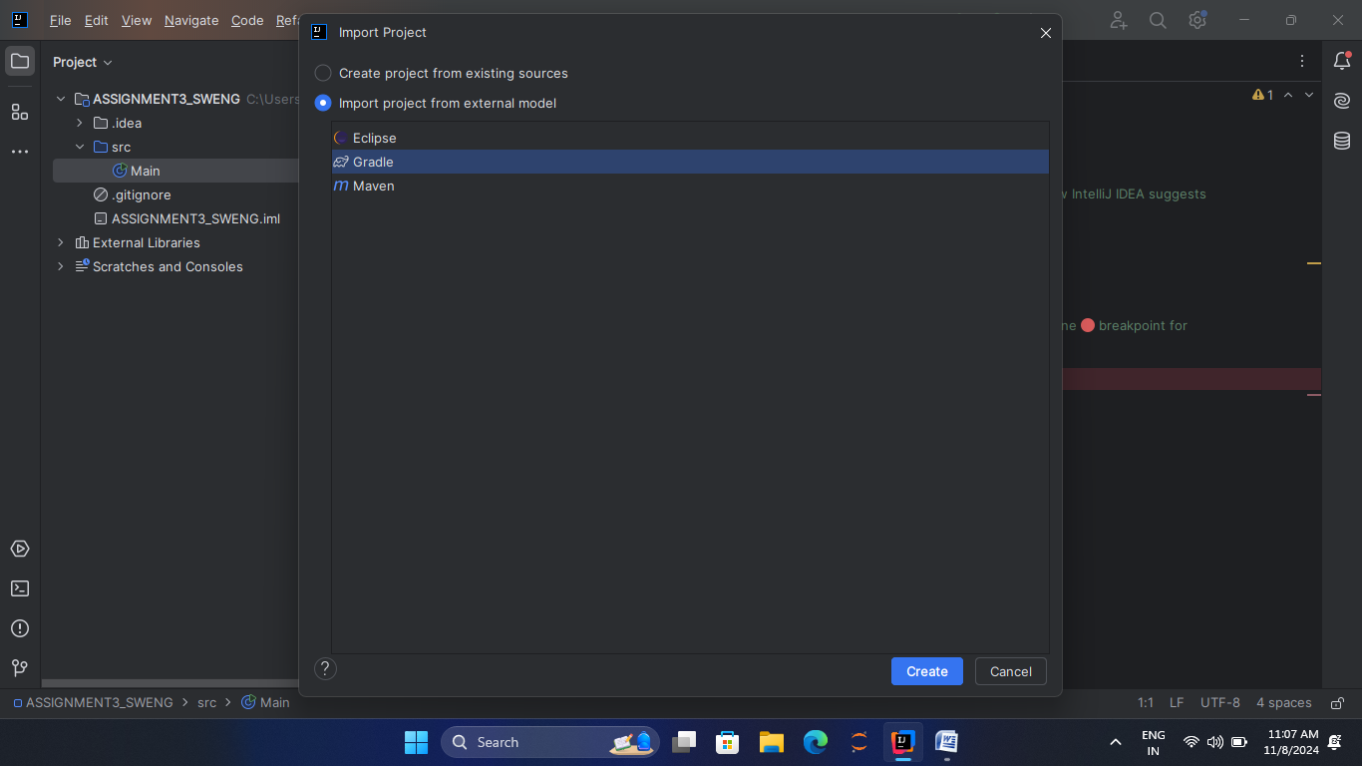

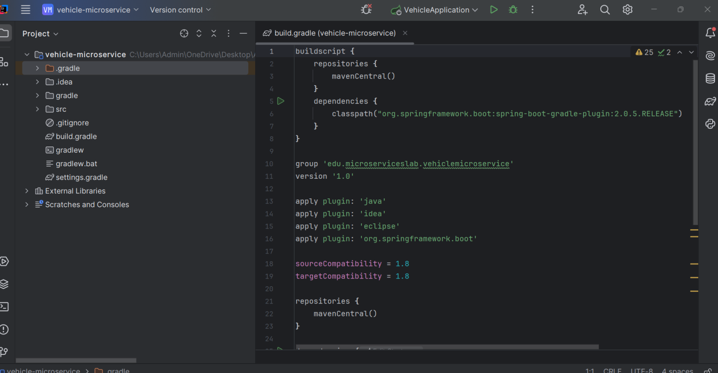

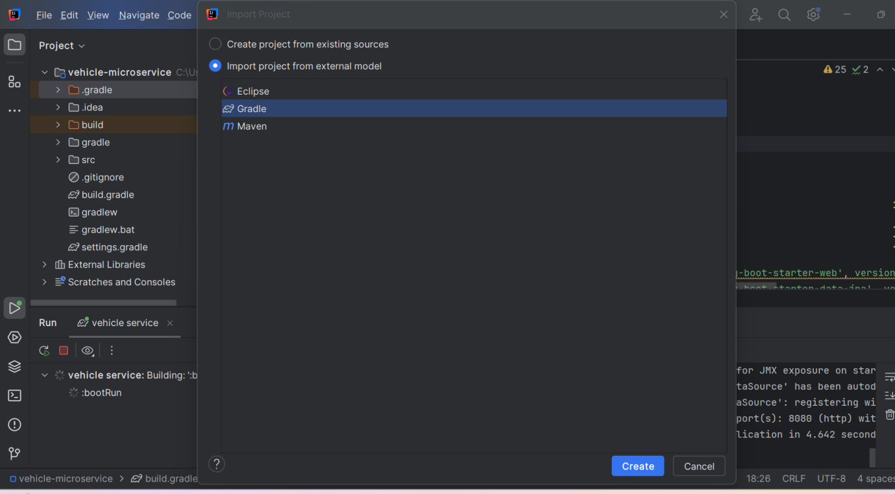

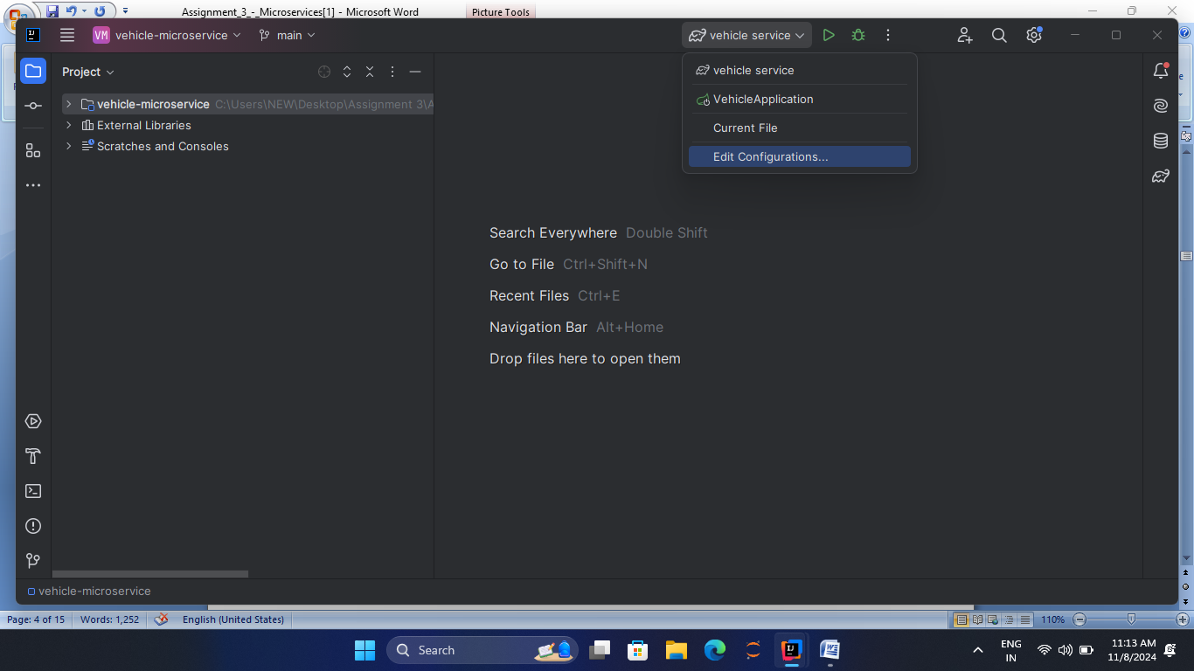

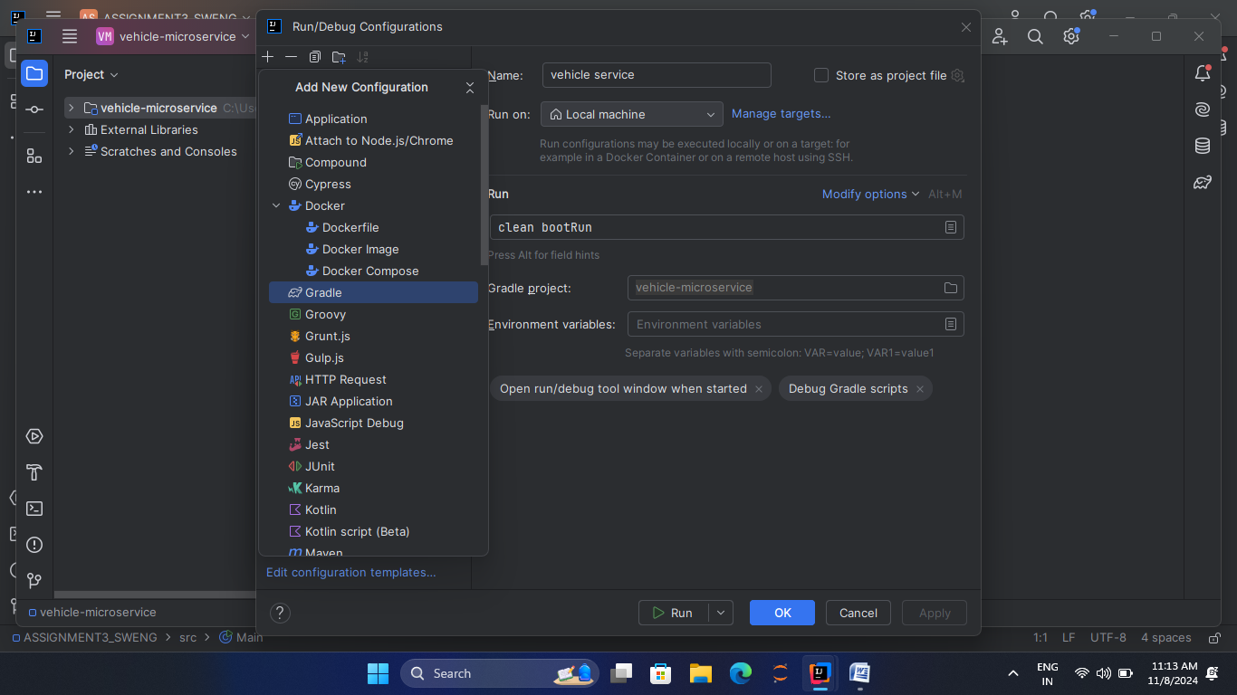

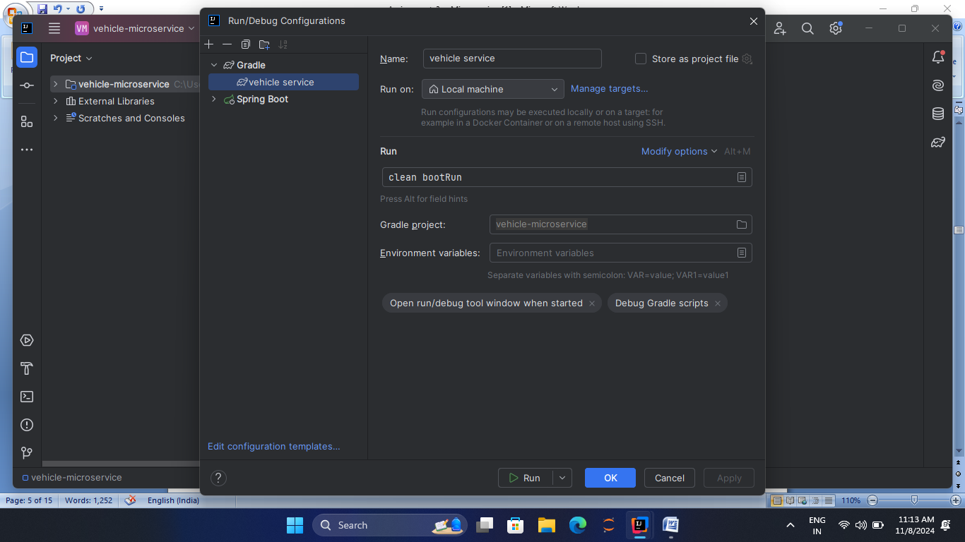

For Gradle project field, click on the folder icon on the right to select the correct microservice. 

In the tasks field enter ‘**clean bootRun’**.



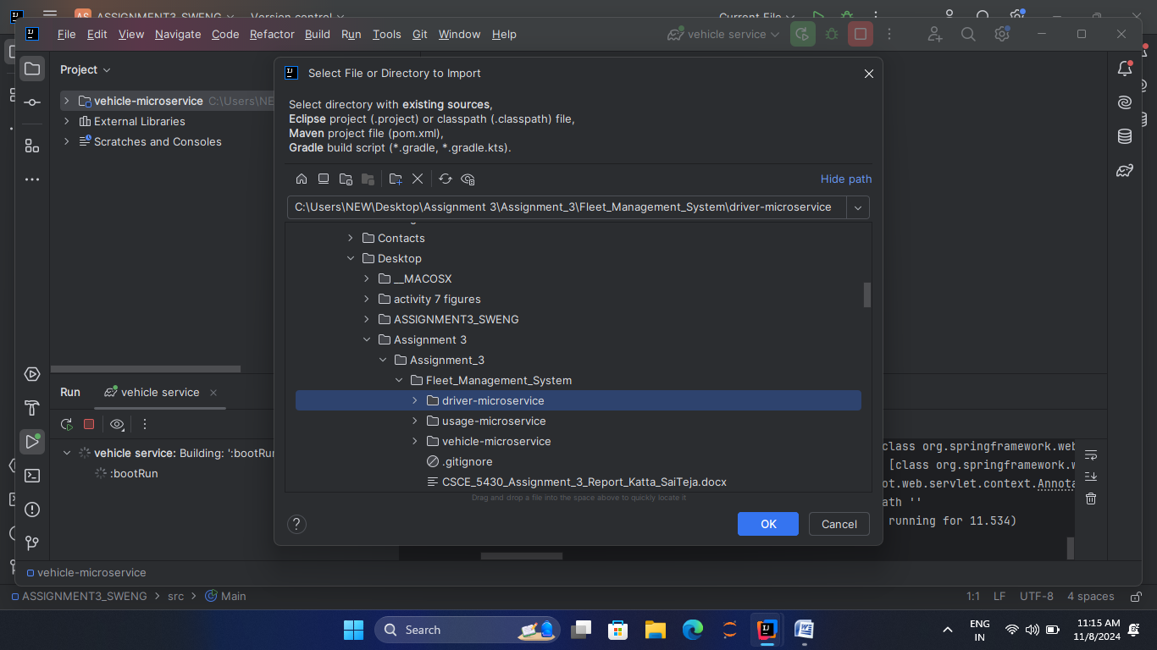

1. Select **Gradle**and open in new window. Then Edit configuration to create new profile and run those projects.

The microservices will be available to respond to requests, each on a separate port as follows:

* The vehicle-micro service endpoint is http://localhost:8080.
* The driver-micro service end point is at http://localhost:8081.
* The usage-micro service will end point is at http://localhost:8082.

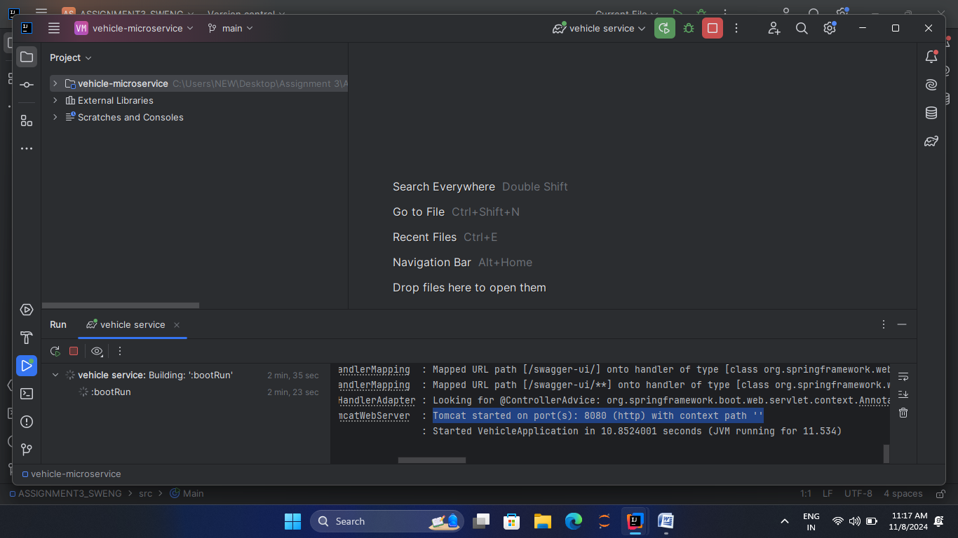

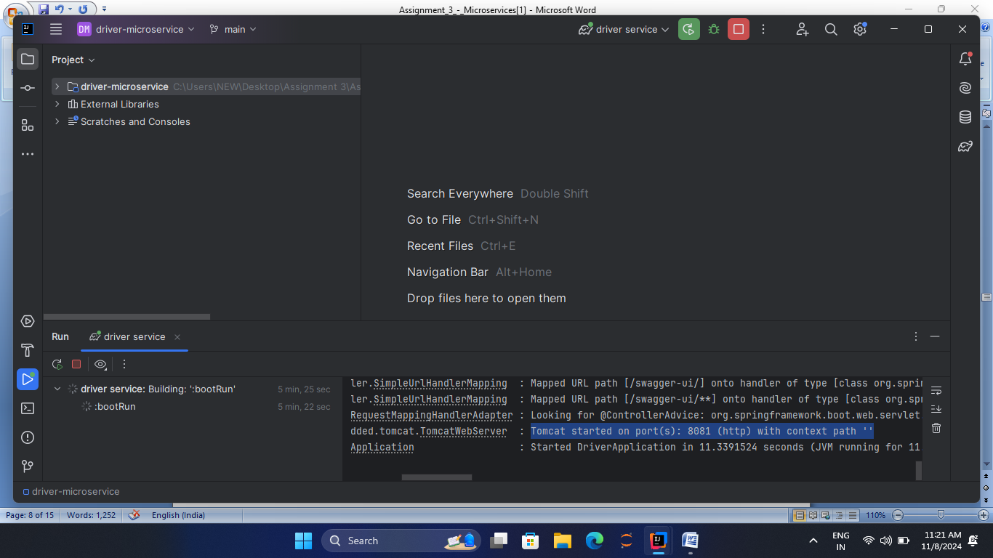

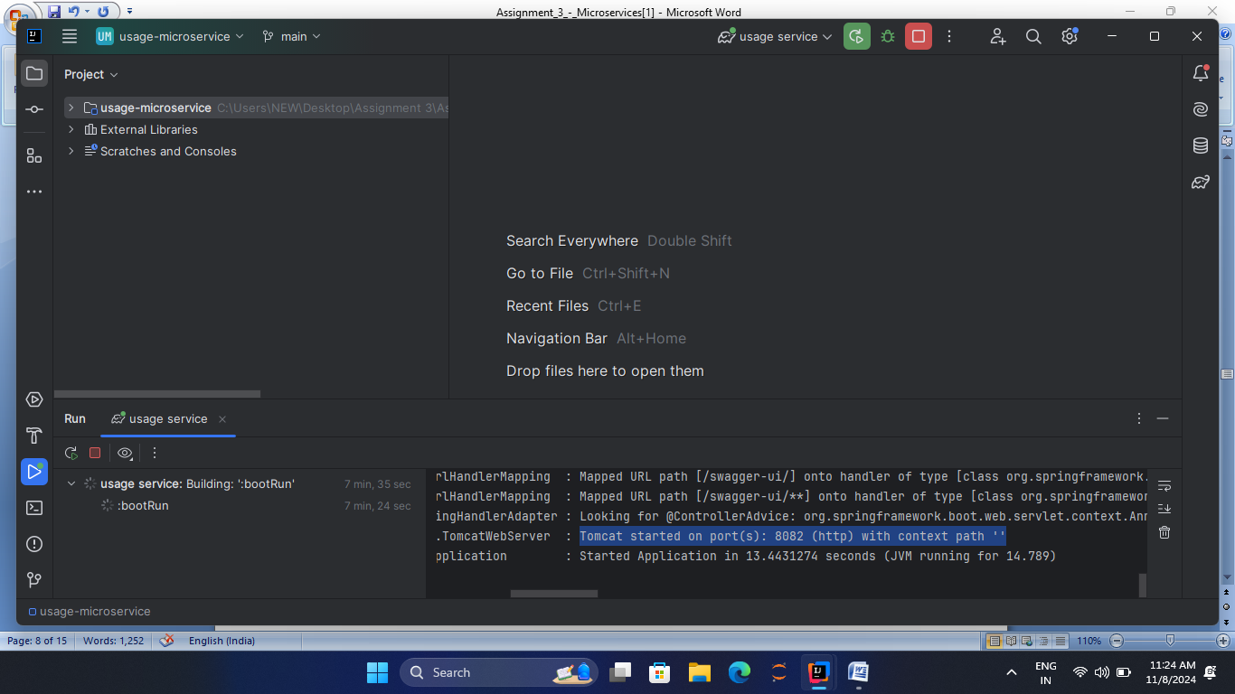

**3.1 Warming up**

1. *How do the microservices communicate with each other?*The main feature in working of a micro service is that it does not depend on any other entities or attributes, it always functions according to its own endpoints and data from its own databases. It is the HTTP-based REST APIs is the mode of communication between the micro services.  
   Let us say there are two micro services MS1 and MS2 which work in order to complete a specific task, assuming the ports of MS1 and MS2 are 8080 and 8081 respectively, then if the MS2 needs to fetch some information from the MS1 then it will call the <http://localhost:8080> from the HTTP request.

The Spring Boot plays a major multiple roles like for using Web Client to handle some king od asynchronous communication so that it sees the REST calls between the services go smoother hence assuring the efficiency of the communication.

1. *How are different classes passed to each together (or instantiated) in Spring*?

In dependency injection there is a specific injection called constructor injection in the Spring where a constructor is used to pass all the required dependencies to a class .In Spring, than initializing the dependencies we can create all of the as constructor parameters where the SpringIoC container handles the dependencies and provides the needed objects while executing.

1. *What is a gradle 'dependency', and how does it help development?*

A reference to an external framework, module or even a library which supports and brings efficiency in the project execution and functioning can be referred to as a gradle dependency. It is visible with the file name build.gradle in the dependies section.

The gradle dependencies help for development in the following ways:

* Sometimes, e encounter the instances where we need to use same code in different areas again and again so rather than coding it every single time , by the gradle dependency the feature of code reusability can be achieved thereby enhancing time and effort.
* As it comes with pre-built components it accelerates out development cycle and also reduces the complex nature in the whole project. Generally pre-built components be the standard functionalities which are frequently used
* Established libraries repeatedly go through rigorous testing and have a community of users and maintainers, leading to better reliability and fewer bugs.

**3.2 Coding**

**Exercise 1 --Extend vehicle microservice**

Initially we will code a controller method which deals with the POST request for inserting vehicles with their information like the registration which ultimately stands as an extention of the micro service vehicle .  
VehicleController.java

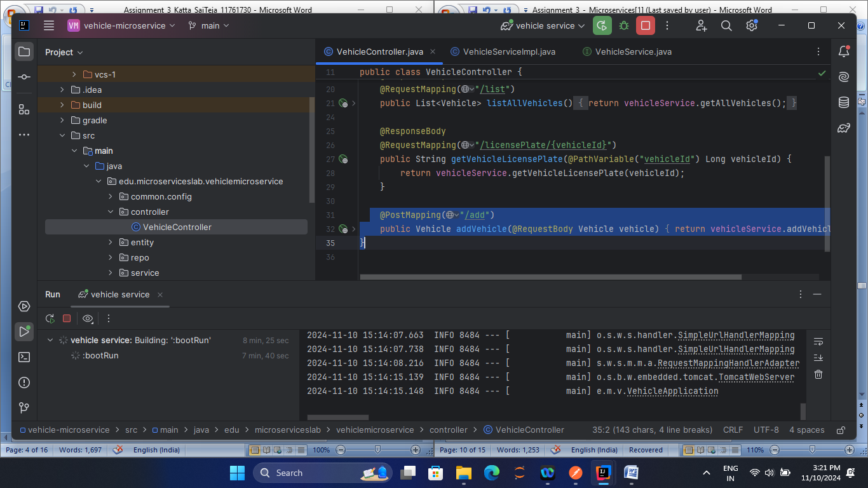

VehicleSrviceImpl.java: implement the addVehicle function in this file  
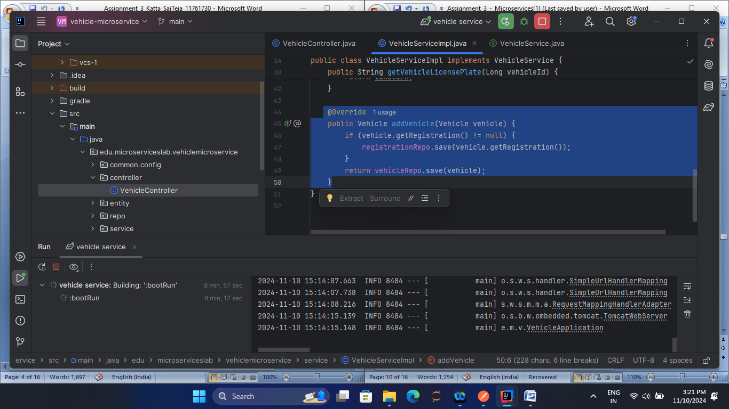

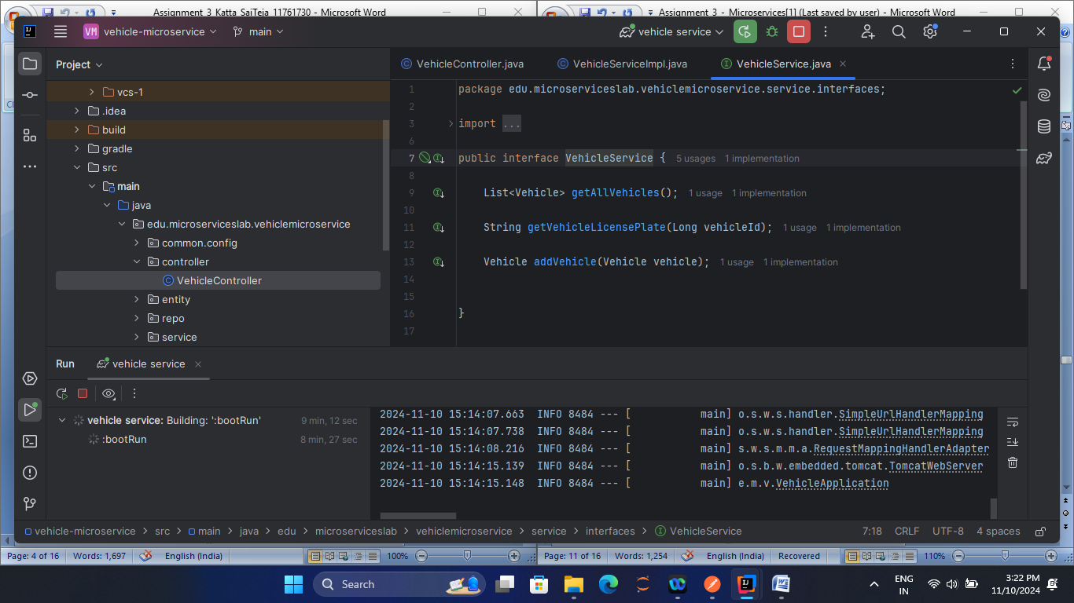  
Test API

* Run Spring Boot Application
* Send a request to <http://localhost:8080/vehicle/add> using the postman tool
* The request is a POST request

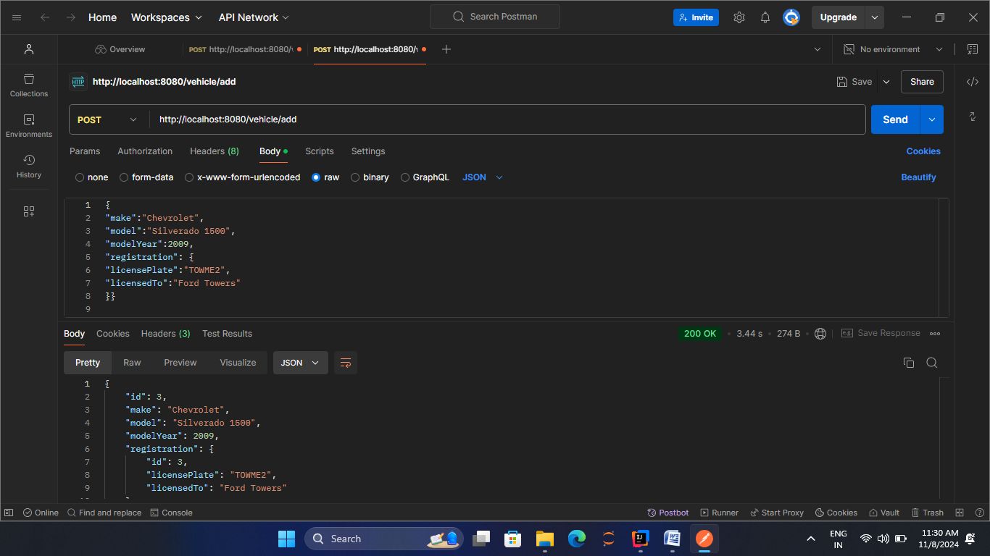

**Exercise 2 - Extend driver microservice**

We need to place a phoneNumber field to the Driver entity of the Driver microservice

* Upgradation: phoneNumber field is added to the Driver Entity
* A new column for the phoneNumber is created by modifying the Database schema.
* Utlity Methods are updated to operate with the phoneNumber field.
* phoneNumber data values are populated.

Driver Entity Code:  
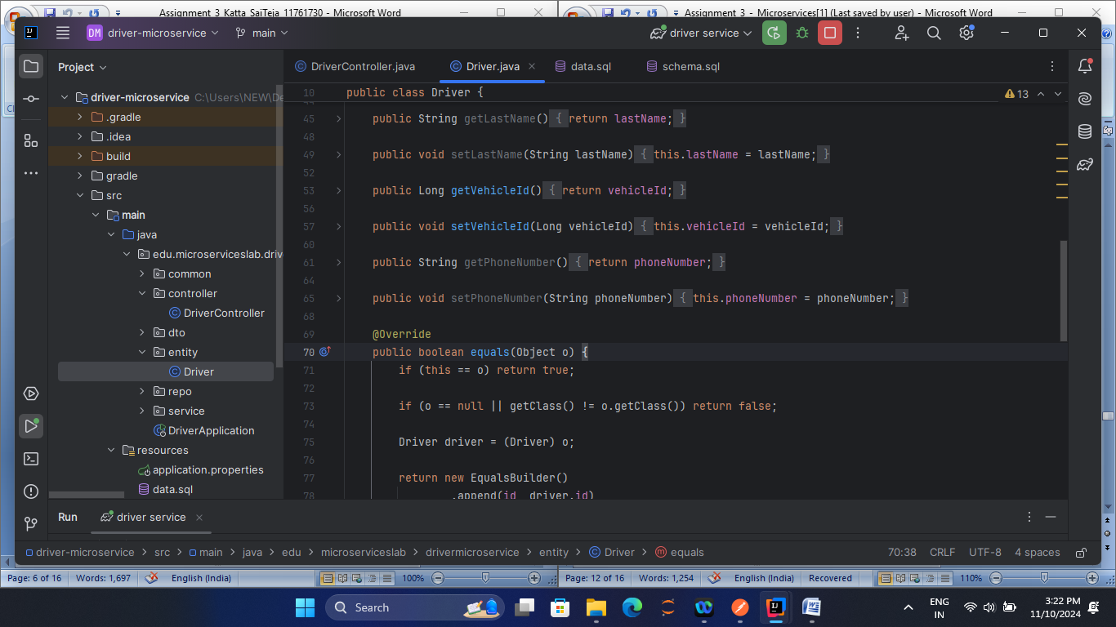

Schema.sql.Code:  
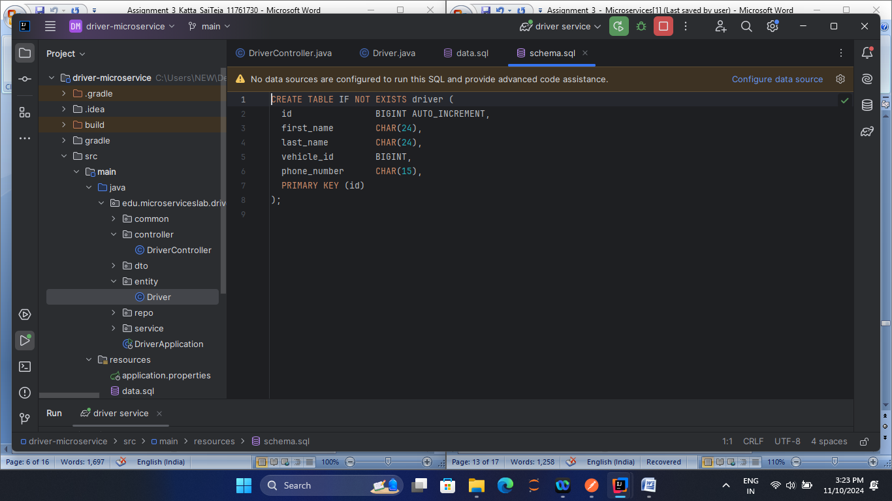

DriverController code:  
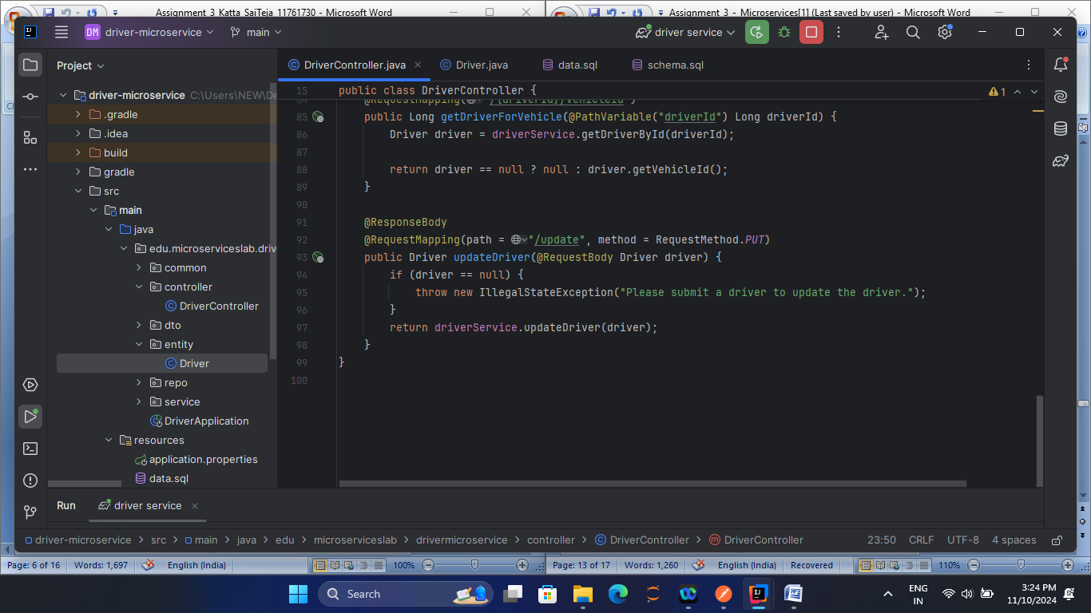 Data.sql command:

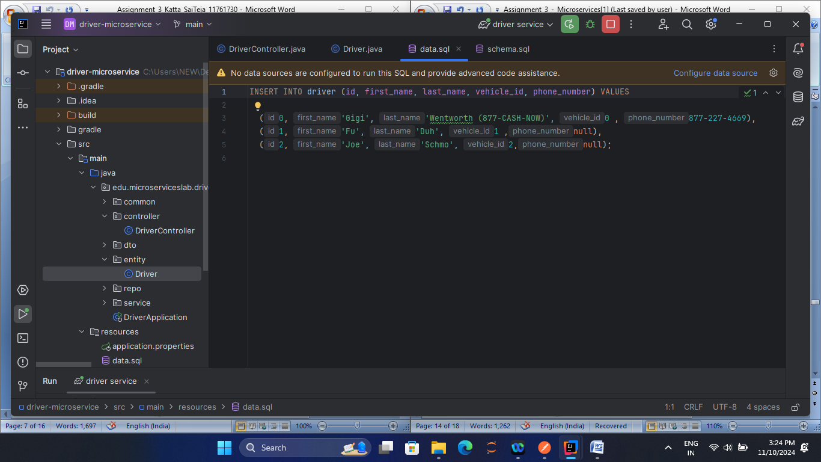  
  
Testing:

Driver record i updated by the POST request of <http://localhost:8081/driver/add>with JSON body:

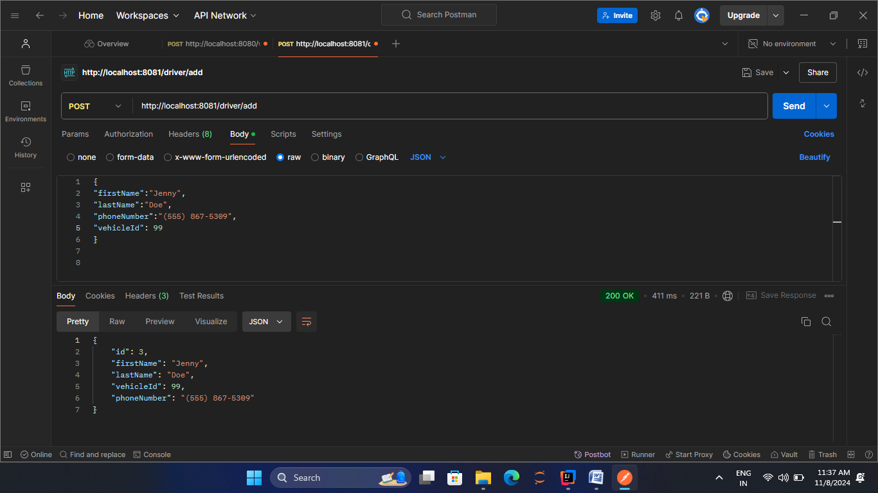

**Exercise 3 -- Extend usage microservice**

To implement a method for holding the statistic data in the Usage-Microservice we require numerous of components are needed to be upgraded like a service, repository an few other resources. Add a method in UsageService for adding new UsageStatistic.

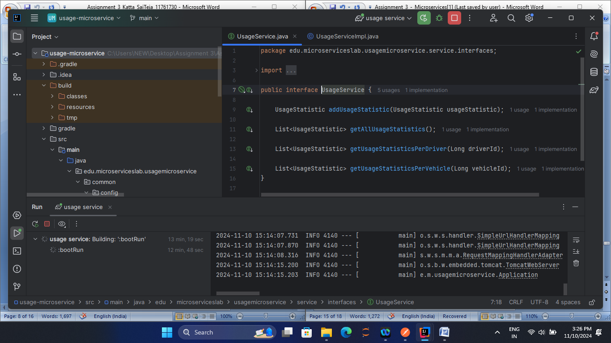In UsageServiceImpl class database add a new UsageSraristic entity.

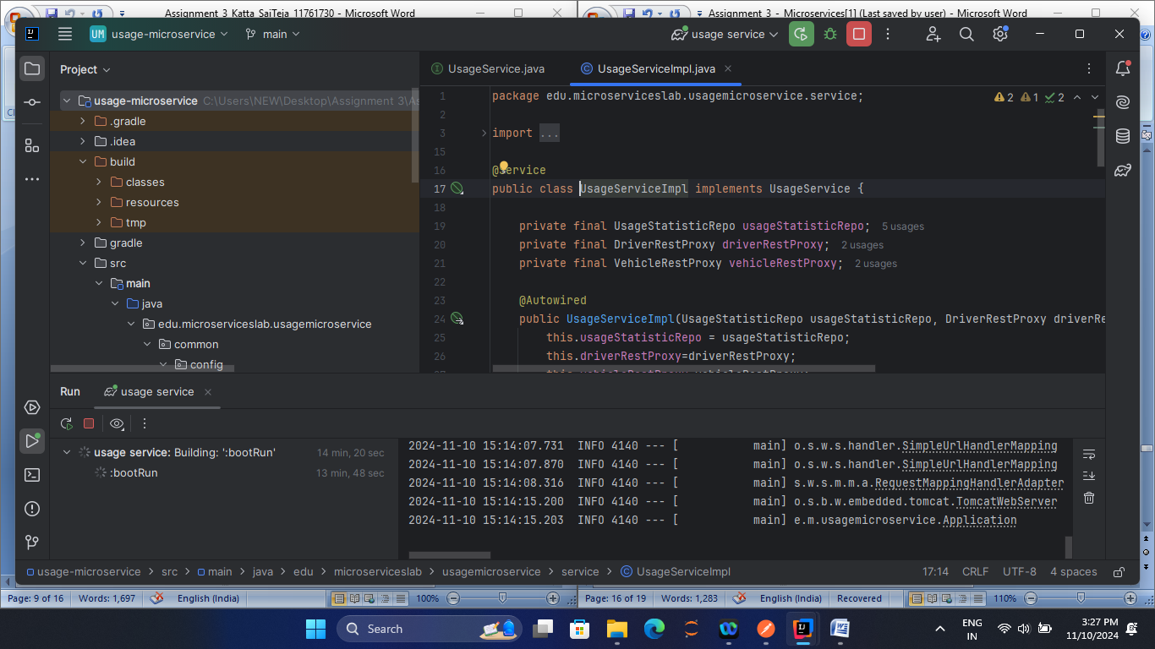

IN usageCOntroller add a method in charge of managing the POST request to add a new usage statistic.

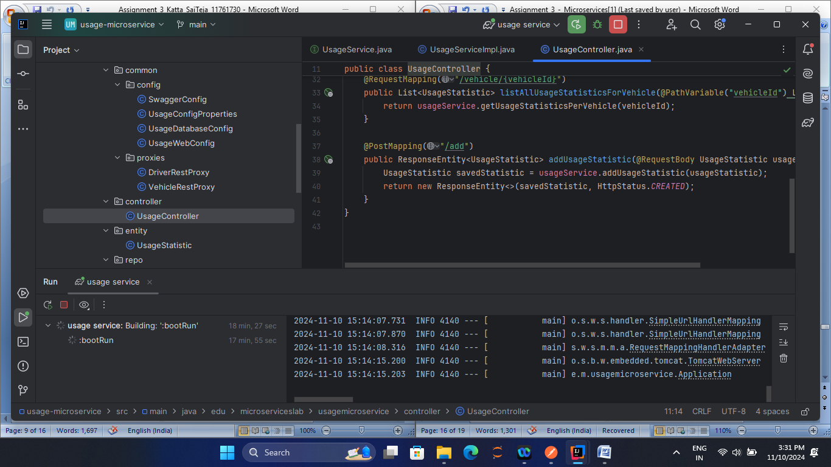  
Testing:

* Use Postman to ad a new usage
* POST a request to path http://localhost:8082/usage/add

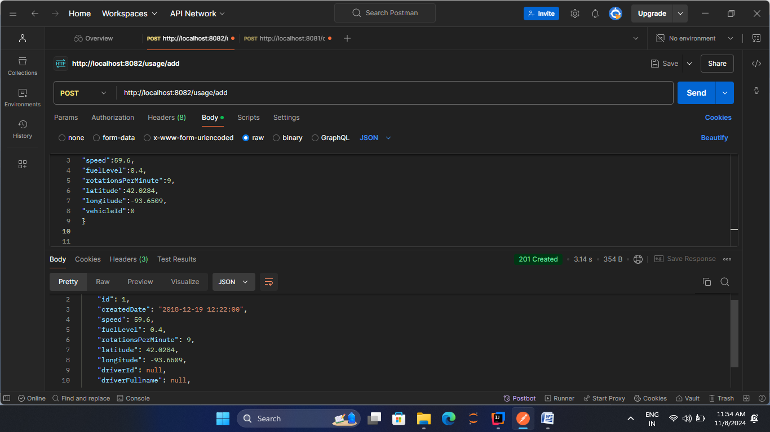

**Exercise 4 - Enforce consistency**

The factor of consistency in the USageServiceImpl class can be provided using following ways:

* Null static data : No incoming data should be null
* Existence of Driver Information: while considering a new UsageStatistic, Check for redundant or repetition of the values or information present.
* Existence of Venicle information : while new UsageStatistic check for existing vehicle in the system for which he Vehicle Service is required.

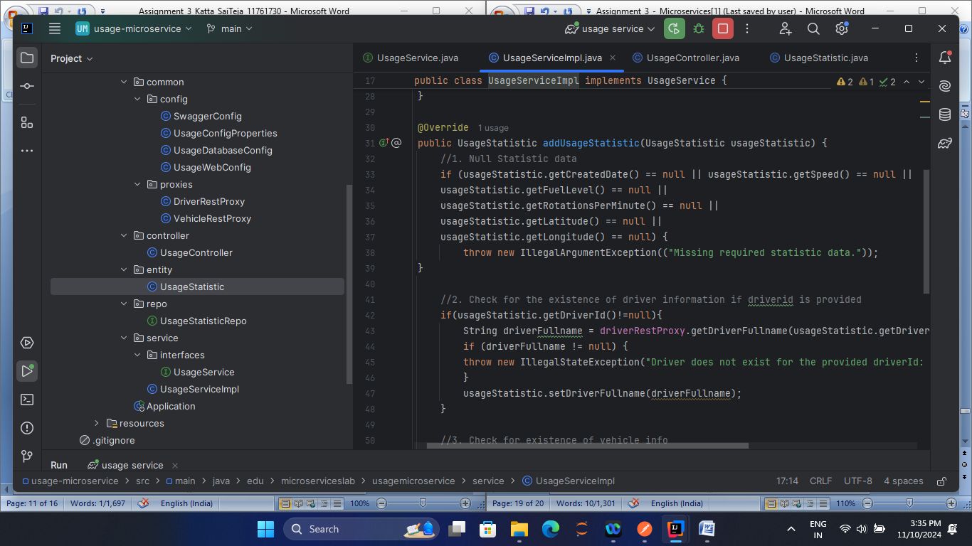  
  
**Exercise 5  - Optional (2 extra credit points)**

First we need to grasp the Springdoc OpenAPI in order to implement Swagger in our Spring Boot microservices. The Springdoc OpenAPI combines with Spring Boor and generates the documentation of the REST API.

Vehicle-microservice

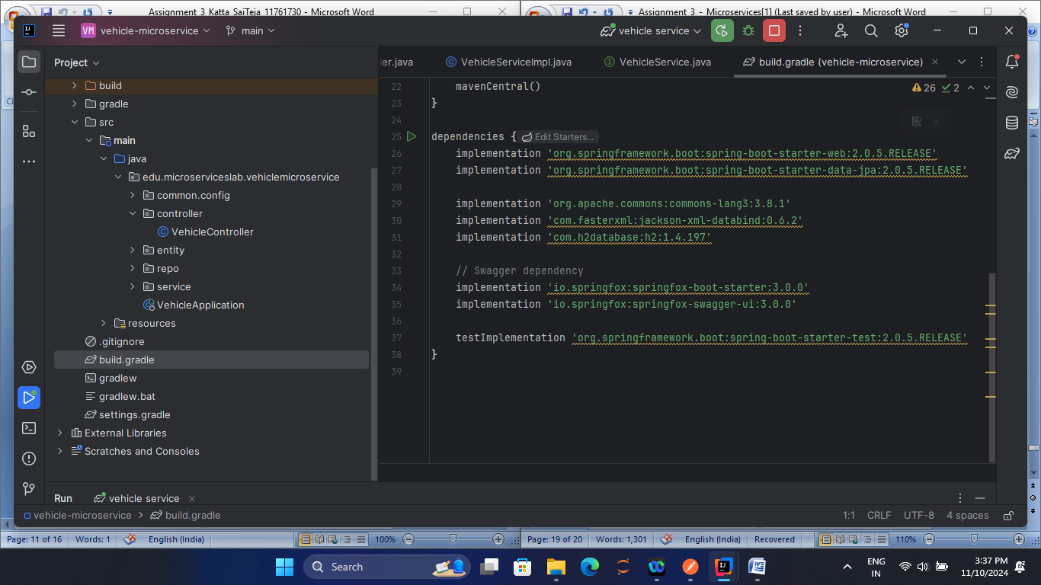

SwaggerConfig.java  
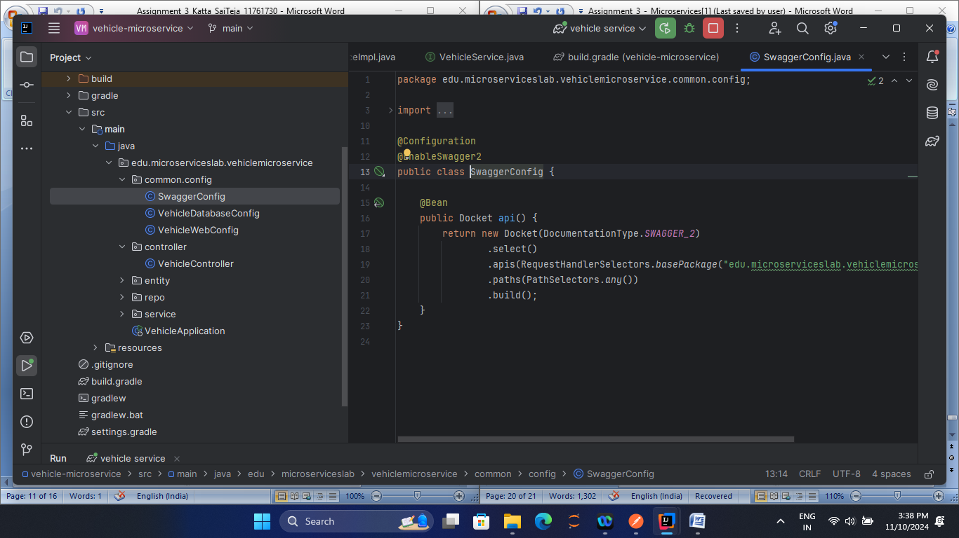

**Vehicle-MicroService Swagger Output in** [**http://localhost:8080/swagger-ui/index.html**](http://localhost:8080/swagger-ui/index.html)

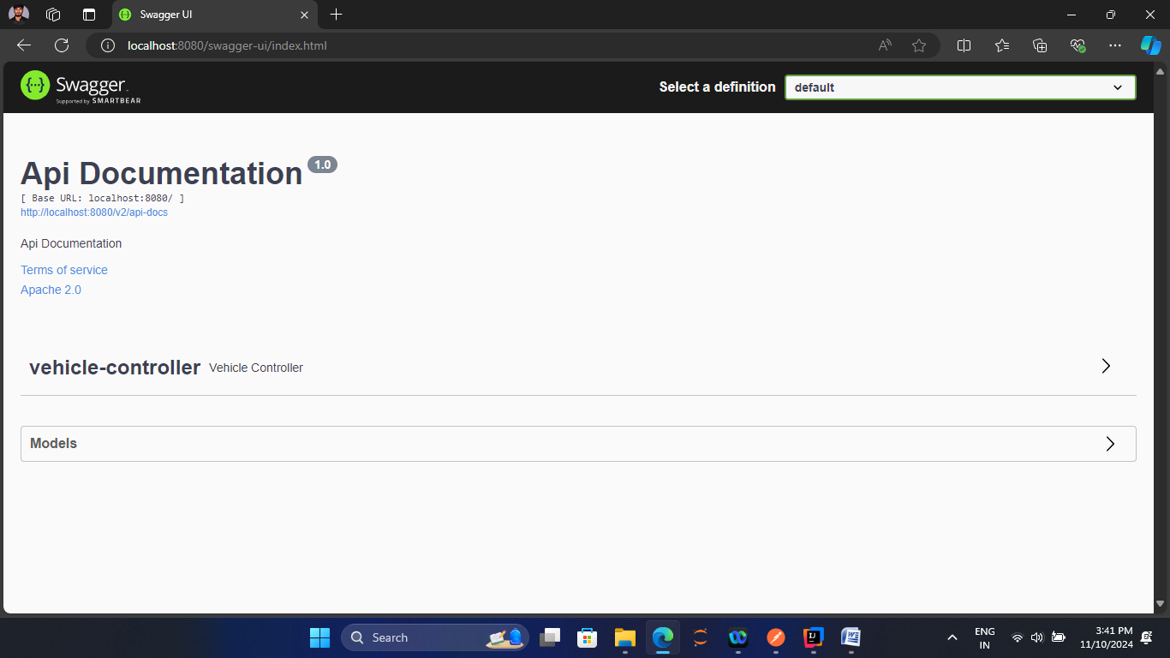

**Driver MicroService**

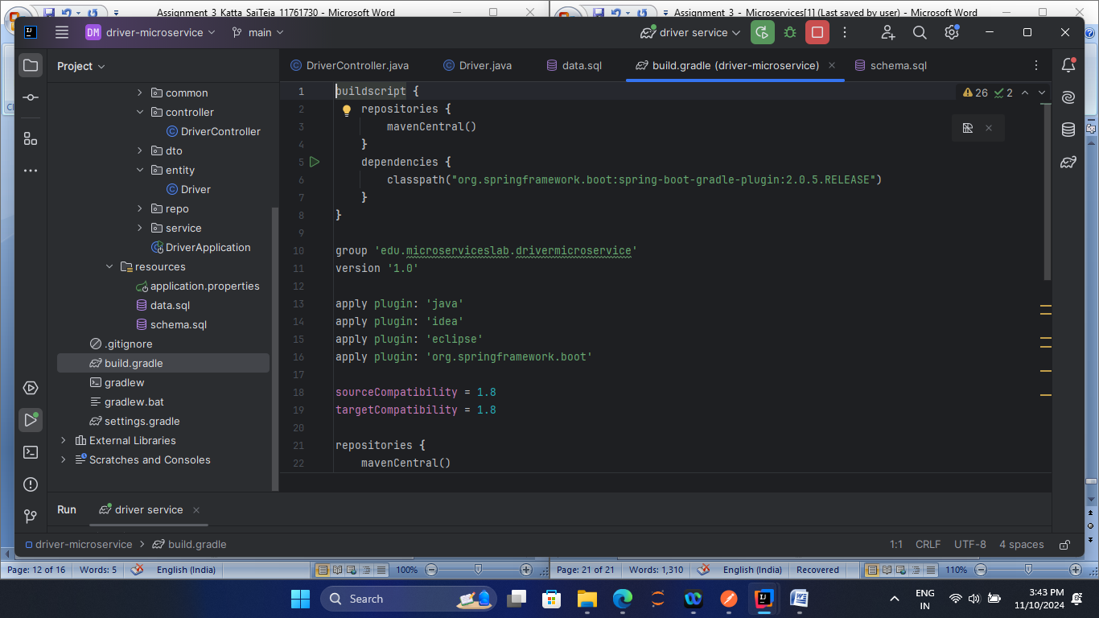

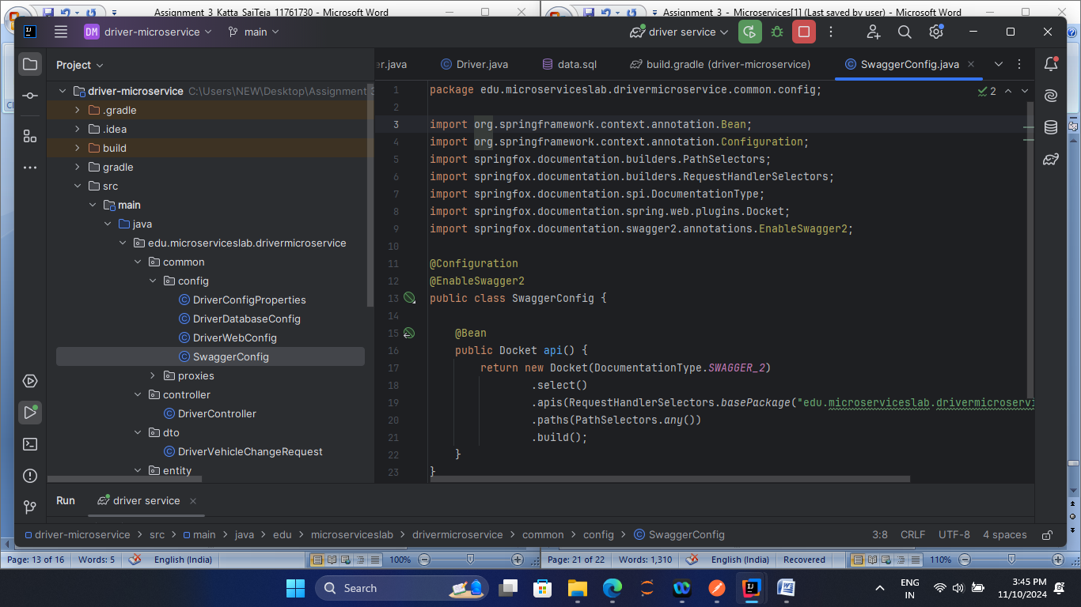

**Driver-MicroService Swagger Output in** [**http://localhost:8081/swagger-ui/index.html**](http://localhost:8081/swagger-ui/index.html)

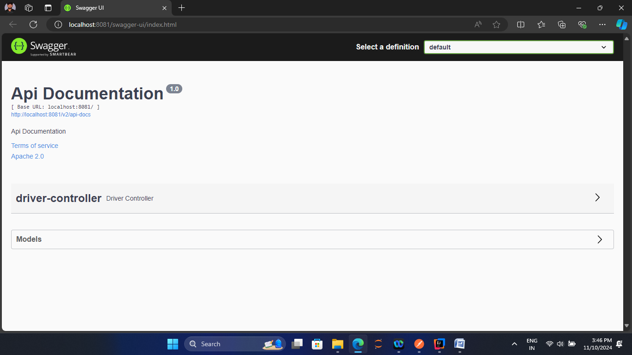

**Usage MicroService**

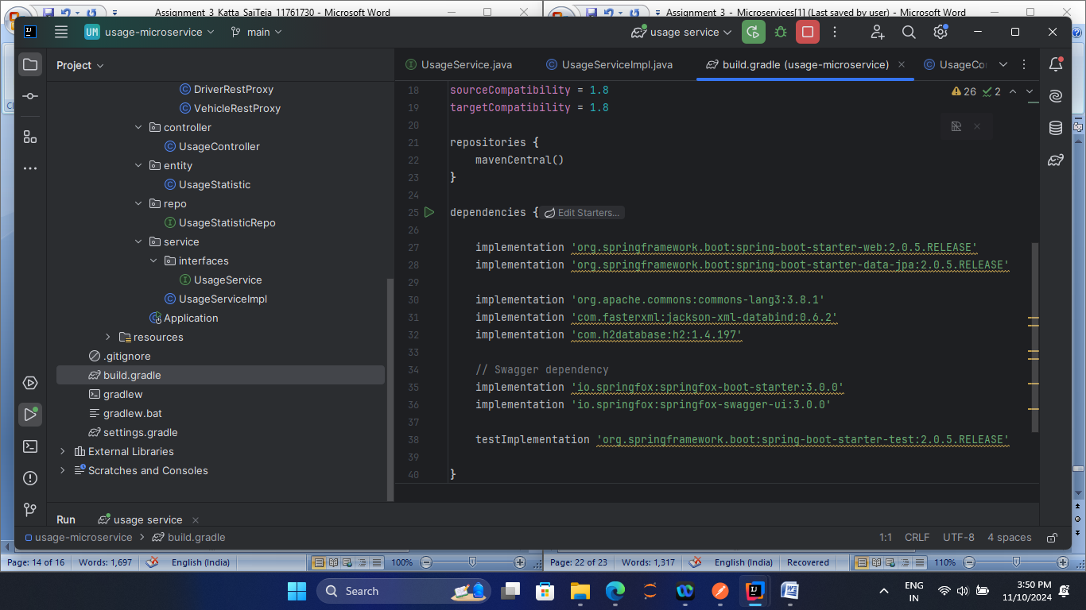

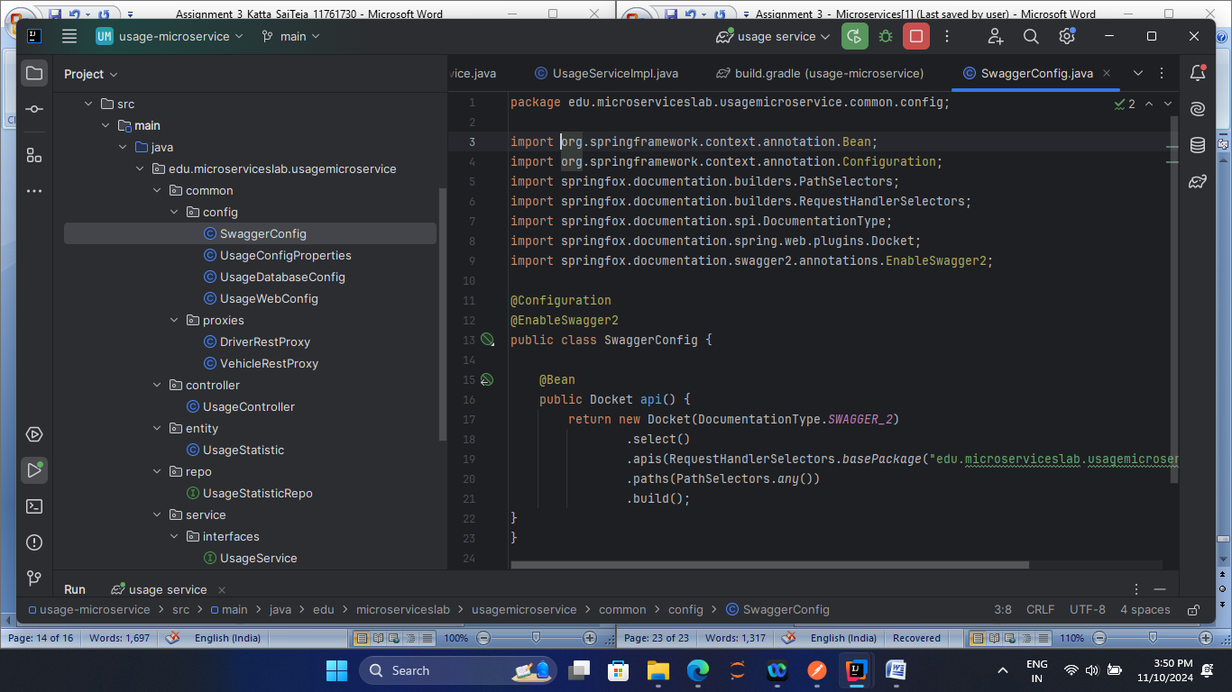

**Usage-MicroService Swagger Output in** [**http://localhost:8082/swagger-ui/index.html**](http://localhost:8082/swagger-ui/index.html)

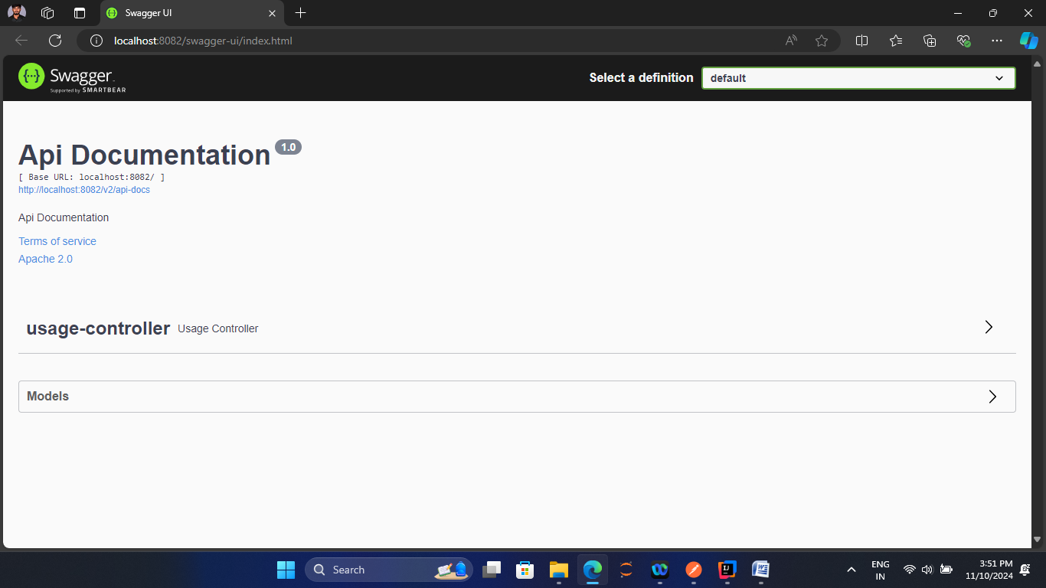

**3.3 Reflection (4 points)**

1) Assume that you discovered a bug in the vehicle microservice.

a) Could the bug cause a crash of all the three microservices?

The architecture of each microservers is built independent and also the communication with others is carried through APIs. Assuming for a bug in one of the micro service, when the bug is localized then it is only restricted to the particular service, Asume it there is failure in establishing connection with the database of a particular microservice where on processed needs to carry out the information to the other microservice then only partial degradation of that particular service might take place as no connection with the data base established , no data is retrieved from the DB by the microservice , no processing, no forwarding of other required stations making others services error our which is an impossible condition.

b) Which microservice(s) do you need to modify to fix the bug?

The vehicle microservice consists of a bug, so only to that the bug fix is required meaning no other microservice rather than the vehicle microservice is touched or interrupted or disturbed here which can be stood as a good isolation keeping others un-disturbed. However , if effected others can work as usual.

c) Assume that you fixed the bug, do you need to deploy all the three microservices again?

2) Would your answers for three questions above be the same if the application were monolithic? (1 point)

3) What lessons did you learn from the assignment? (1 point)

**4. Submission requirements and grading criteria**

Submit a zip file that includes a report answering questions 1-3 and the code of each microservice starting with the root folder.

**5. Acknowledgment**  
Special thanks to Thomas Stackhouse and Nischay Venkatram for helping to develop this assignment.